Welcome!
Date
Name
Spouse
Address
City
State Zip _________
Email

Please Contact By
❑ Card  Phone  Visit

Telephone Best Time to Call
Home ______________
Work ______________

Guest: First Time Second Time
Are you a church member: yes no
Church
City, State

Circle Appropriate Age/Grade Group(s)
Preschool: Ages: B-1 2-3 4-5
Children: Grades: K 1 2 3 4 5 6
Youth: Grades: 7 8 9 10 11 12
Adults: Ages:18-29 30s 40s 50s 60s+

How did you learn about our church?
Newspaper Friend Yellow Pages Mail
Other

I am a guest of:

New in the Community? Yes No
Names & ages of children at home

Weekly Service & Activity Schedule
November 17, 2013
9:45 a.m. Sunday School
11:00 a.m. Morning Worship

6:00 p.m. Evening Service

Week of November 18 – 23

Wednesday, 6:30 p.m. Youth Activities
Wednesday, 6:45 p.m. Adult Prayer & Bible Study
Wednesday, 7:30 p.m. Praise Team Rehearsal
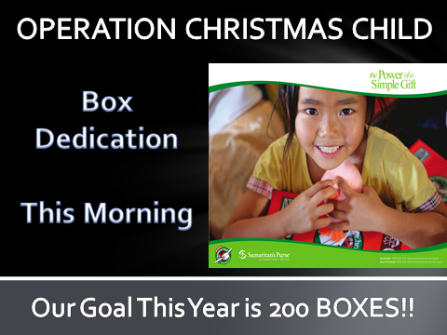
Thanksgiving Meals Baskets
Every year we reach out to families that are in need. If you would like to help in this ministry, the next few weeks we’ll be collecting items. There is a sign-up sheet at the church. Together we all can spread our love and supply these families with a Thanksgiving meal. Please contact Evelyn Robinson to help!!
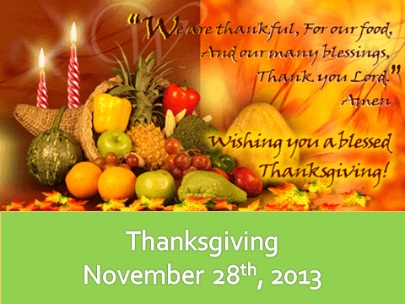
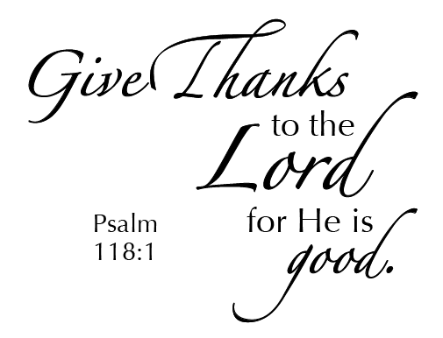

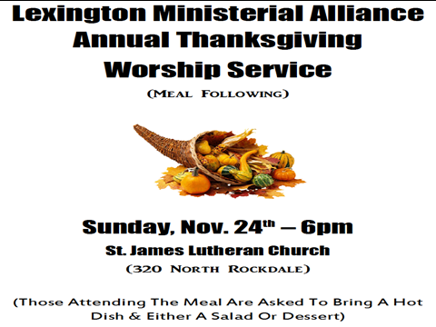
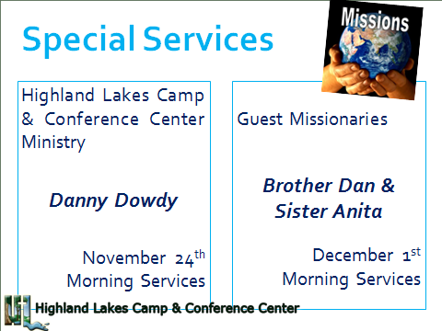
Knobbs Springs Baptist Church

“I cry out to you, God, but you do not answer;
I stand up, but you merely look at me.
You turn on me ruthlessly;
with the might of your hand you attack me.
You snatch me up and drive me before the wind;
you toss me about in the storm.
I know you will bring me down to death,
to the place appointed for all the living.
“Surely no one lays a hand on a broken man when
he cries for help in his distress.
Have I not wept for those in trouble?
Has not my soul grieved for the poor?
Yet when I hoped for good, evil came;
when I looked for light, then came darkness.
The churning inside me never stops;
days of suffering confront me.
I go about blackened, but not by the sun;
I stand up in the assembly and cry for help.
I have become a brother of jackals, a companion of owls. My skin grows black and peels;
my body burns with fever. My lyre is tuned to
mourning, and my pipe to the sound of wailing.
Job 30:20-31

November 17, 2013

Church Information:
KnobbsSpringsBC.com KnobbsSpringsBaptist@gmail.com
1662 CR 305, McDade, Texas 78650 512-273-2743
Brother Dwight Reagan 512-247-6448
Kimberly Tabor, Office Manager 512-698-2804

